Ideation Phase
Define the Problem Statements

Date | 23 June 2026
Team ID
Project Name | An employee requests installation of licensed software through the Service Catalog
Maximum Marks | 2 Marks

Customer Problem Statement Template:
The Customer Problem Statement was created to understand the needs, challenges, and expectations of employees who request software installations within an organization. By identifying the user's goals, obstacles, and emotions, the project focuses on solving the real problems experienced during the software request process.
In this project, the primary customer is an employee who needs software to perform daily work efficiently. Traditional software request methods often involve manual emails, multiple approval steps, and limited visibility into request status, leading to delays and frustration. Understanding these challenges helped define the requirements for an automated solution.
The Customer Problem Statement guided the development of the Software Installation Request Automation system in ServiceNow. The solution simplifies software request submission through the Service Catalog, automates approval workflows, creates fulfillment tasks, provides real-time request tracking, and improves communication between employees and the IT support team. This user-centered approach ensures that the solution addresses customer needs while improving efficiency, transparency, and overall user satisfaction.
Software Installation Request through catalog
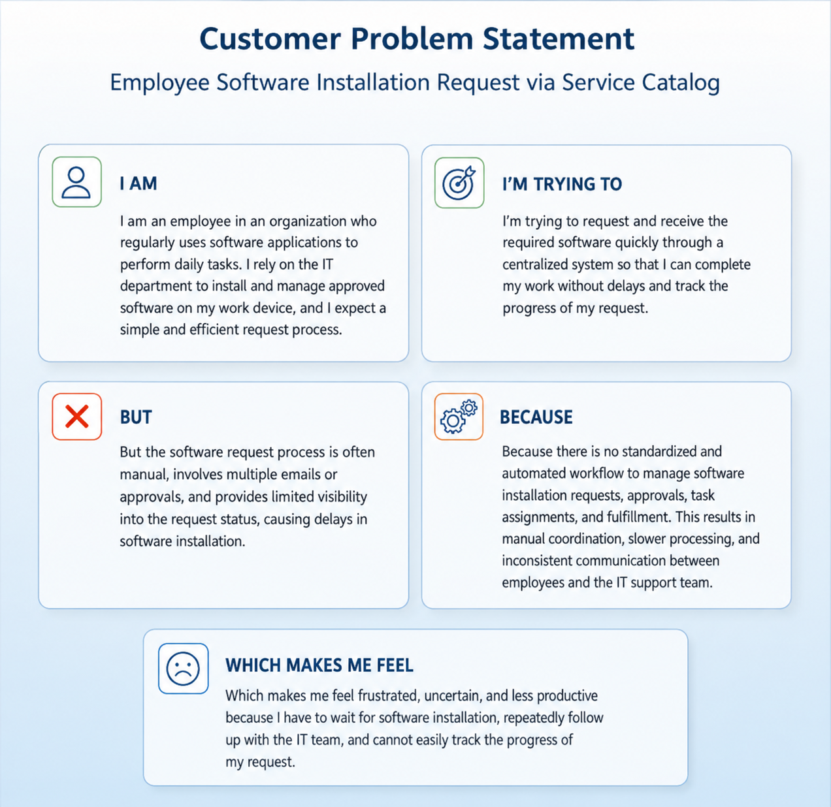
Problem Statement (PS) | I am (Customer) | I’m trying to | But | Because | Which makes me feel
PS-1 | An employee who needs software to perform daily work. | Request and receive approved software quickly through ServiceNow. | The request process is slow and I cannot easily track its progress. | The process involves manual approvals and limited visibility into the request status. | Frustrated, uncertain, and less productive.
PS-2 | An IT Support Engineer responsible for software installations. | Process software installation requests efficiently and on time. | I receive incomplete request information and must coordinate manually with users and approvers. | The request process is not fully automated and lacks standardized workflows. | Overloaded, delayed, and prone to processing errors.

